Case 0:

SalesOrder(CustNo,CustName,CusAddress,**SOnumber**,SODate,cleckNo,CleckName,itemNo, Desc,quantity,unitPrice,Total)

**First Normalization 1N:**

SaleOrder(**SOnumber**,SODate,ClerkNo,ClerkName,CustNo,CustName,CustAddress)



Items(SOnumber,itemNo,Desc,Quantity,UnitPrice,Total)

**Second Normalization 2N:**

SaleOrder(**SOnumber**,SODate,ClerkNo,ClerkName,CustNo,CustName,CustAddress)

Item(ItemNo,Desc,UnitPrice)

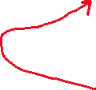

Item_sales(SOnumber,itemNo,Quantity)

**Third Normalization 3N:**

SaleOrder(**SOnumber**,SODate,ClerkNo,CustNo)

Clerk(ClerkNo,ClerkName)

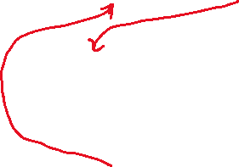

Item(ItemNo,Desc,UnitPrice)



Item_sales(SOnumber,itemNo,Quantity)



Customer(CustNo,CustName,CustAddress)

Case 0:

Department(DeptNo,DeptName,Location,MgrName,MgrIdNo,telExtn,CustNo,CustName, DateOfComplaint,NatureOfcomplaint)

**First Normalization 1N:**

Department(DeptNo,DeptName,Location,MgrName,MgrIdNo,TelExtn)



Customer_Dept(CustNo,DeptNo,CustName,DateOfComplaint,NatureOfComplaint)

**Second Normalization 2N:**

Department(DeptNo,DeptName,Location, MgrIdNo,MgrName,TelExtn)

Customer(CustNo,CustName)

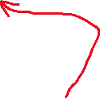

Customer_Dept(CustNo,DeptNo,DateOfComplaint,NatureOfComplaint)

**Third Normalization 3N:**

Department(DeptNo,DeptName,Location, MgrIdNo,TelExtn)

Manager(MgrNo,MgrName)

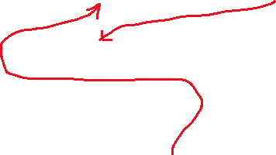

Customer(CustNo,CustName)



Customer_Dept(CustNo,DeptNo,DateOfComplaint,NatureOfComplaint)